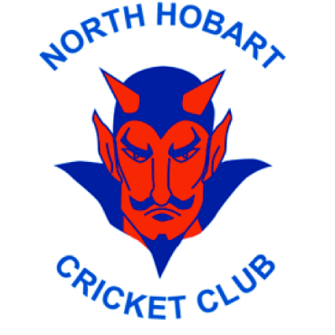
North Hobart Cricket Club
Callum Jones Memorial Award

Callum Jones was a young teenager with a great love of sport.
He was an accomplished junior footballer with the North Hobart Football Club, winning the under 16 goal kicking at North in 2010. Callum was also well on his way to play at the top level of cricket. Callum was captain of the North Hobart 2008/09 under 15 premiership side and was a major part of the 2009/10 State Under 15 team.
At the age of 16 Callum’s world was turned upside down when he was diagnosed with a tumour on his left shoulder. Callum battled through intensive treatment in both Hobart and Melbourne. To the amazement of many, his attitude continued to be positive and his courage in the face of his fight with cancer was inspirational. There is no doubt that Callum’s influence was present when the Demons won their first under 17 premiership in season 2011/12.
Callum lost his battle in October 2012 and we are all the poorer for his passing.
The Callum Jones trophy is given in memory of him.

LIST OF AWARD WINNERS

YEAR | WINNER (S)
2012/13 | Jack White
2013/14 | Caleb Jewell
2014/15 | Luke Williams
2015/16 | Jim Bower
2016/17 | Samantha Rogers
2017/18 | Sam Lewis-Johnson
2018/19 | Nick Davis
2019/20 | Grace Pullen
2020/21 | Jack Callinan
2021/22 | Melodie Armstrong
2022/23 | Hamish Beechey

